Part 1:

Step 1: 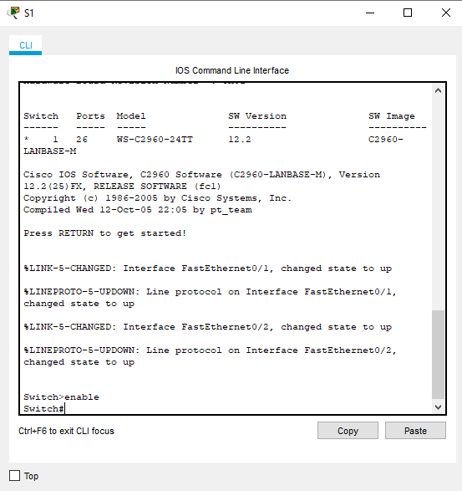

Step 2:

* 24 fast ethernet switches
* 2 gigabit ethernet switches
* 0-4 and 5-15
* startup-config is not present
* because the start up configuration hasn't been saved yet

Part 2:

Step 1: 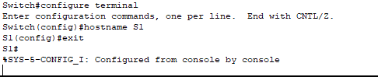

Step 2: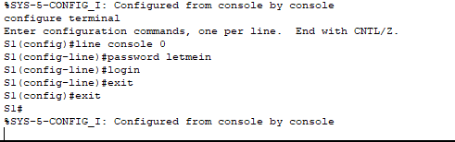

* without the login command the user will never be prompted to login and thus wont be able to do anything

Step 3: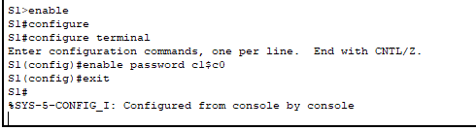

Step 4: 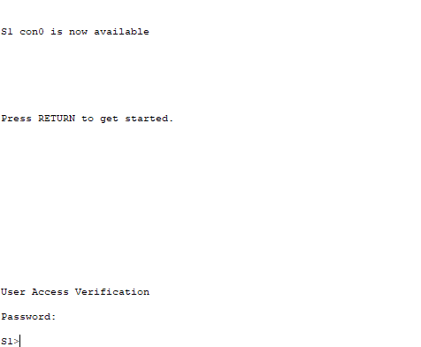

Step 5: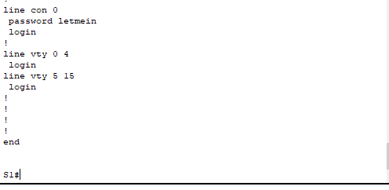

Step 6: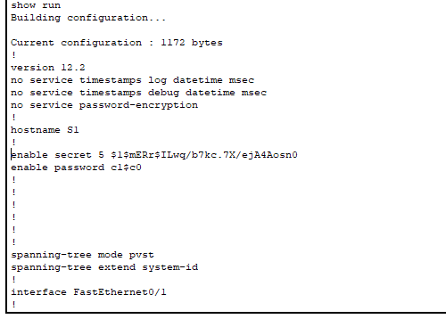

Step 7: 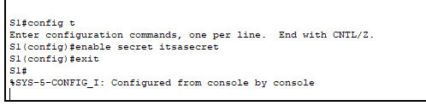

* enable secret 5 $1$mERr$ILwq/b7kc.7X/ejA4Aosn0
* Because it is encrypted

Step 8: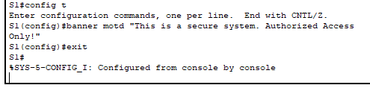

* They will be in encrypted format as it is setting all passwords new and old to be encrypted

Part 3:

Step 1: 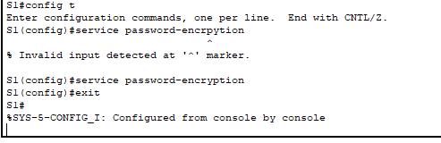

* Every time a user logs in
* To warn unauthorized users that it is prohibited and to send messages to authorized users

Part 4:

Step 1: 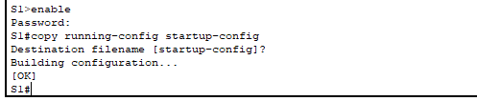

* Copy run start
* show startup-configuration
* yes all the changes were saved

Part 5:

